### **Black Box Testing**

| **Cause** |  | **Values** | **1** | **2** | **3** | **4** | **5** |
| --- | --- | --- | --- | --- | --- | --- | --- |
| **C1** | Received | Y/N | N | Y | Y | Y | Y |
| **C2** | Have not Received | Y/N | N | N | Y | Y | Y |
| **C3** | Received | Y/N | - | - | N | Y | Y |
| **C4** | Have not Received | Y/N | - | - | - | N | Y |
| **Effect** |  |  |  |  |  |  |  |
| **E1** | Accept |  |  |  |  |  | x |
| **E2** | Reject |  | x | x | x | x |  |

**Reduced Decision Table for Receiving Data**

| **Test Scenario** | **Test case** | **Pre-condition** | **Test Steps** | **Test Data** | **Expected Result** | **Actual Result** | **Pass / Fail** |
| --- | --- | --- | --- | --- | --- | --- | --- |
| Check if data have been received from other components | Check if data have been received from IR and Ultrasonic |  | 1.Run the car  2.IR reads the data  3.IR sends the data  4.Ultrasonic reads the data  5.Ultrasonic sends the data | IR reads data: “ABC”  IR sends data: “ABC”  Ultrasonic reads data: “DEF”  Ultrasonic sends data: “DEF” | Data must be read successfully and be received from all components | Data successfully received from all components | Pass |
| Check if data have been received from other components | Check if data have been received from IR and Ultrasonic |  | 1.Run the car  2.IR reads the data  3.IR sends the data  4.Ultrasonic reads the data  5.Ultrasonic sends the data | IR reads data: “”  IR sends data: “”  Ultrasonic reads data: “”  Ultrasonic sends data: “” | Data read and receive failed | Data read and receive failed | Fail |
| Check if data have been received from other components | Check if data have been received from IR and Ultrasonic |  | 1.Run the car  2.IR reads the data  3.IR sends the data  4.Ultrasonic reads the data  5.Ultrasonic sends the data | IR reads data: “ABC”  IR sends data: “”  Ultrasonic reads data: “”  Ultrasonic sends data: “” | Data read and receive failed | Data read and receive failed | Fail |
| Check if data have been received from other components | Check if data have been received from IR and Ultrasonic |  | 1.Run the car  2.IR reads the data  3.IR sends the data  4.Ultrasonic reads the data  5.Ultrasonic sends the data | IR reads data: “ABC”  IR sends data: “ABC”  Ultrasonic reads data: “”  Ultrasonic sends data: “” | Data read and receive failed | Data read and receive failed | Fail |
| Check if data have been received from other components | Check if data have been received from IR and Ultrasonic |  | 1.Run the car  2.IR reads the data  3.IR sends the data  4.Ultrasonic reads the data  5.Ultrasonic sends the data | IR reads data: “ABC”  IR sends data: “ABC”  Ultrasonic reads data: “DEF”  Ultrasonic sends data: “” | Data read and receive failed | Data read and receive failed | Fail |

**Testing Table for Receiving Data**

### 

### 

### 

### **White Box Test**

**M5Stick UART MSPIO.c Switch Case**

**Nodes:** 28

**Edges:** 25

Cyclomatic Complexity (M) = (E - N + 2(P)), Assuming P = 1,

**M** = 28 - 25 + 2(1)

= 5

**Basis Paths:**

**Path 1:** 1 - 2 - 3 - 4 - 5 - 6 - 25

**Path 2:** 1 - 2 - 3 - 4 - 5 - 6 - 7 - 8 - 9 - 25

**Path 3:** 1 - 2 - 3 - 4 - 5 - 6 - 7 - 10 - 11 - 12 - 13 - 14 - 15 - 24 - 25

**Path 4:** 1 - 2 - 3 - 4 - 5 - 6 - 7 - 10 - 11 - 16 - 17 - 18 - 19 - 24 - 25

**Path 5:** 1 - 2 - 3 - 4 - 5 - 6 - 7 - 10 - 11 - 20 - 21 - 22 - 23 - 24 - 25

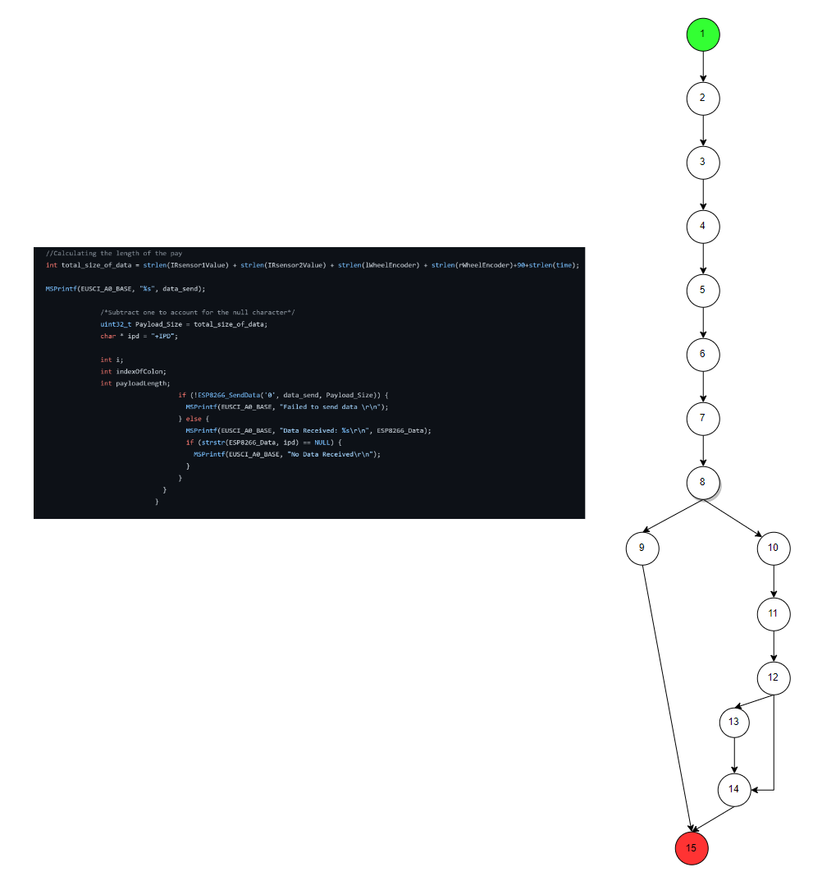

**ESP01 UART If Else**

**Nodes:** 15

**Edges:** 16

Cyclomatic Complexity (M) = (E - N + 2(P)), Assuming P = 1,

**M** = 16 - 15 + 2(1)

= 3

**Basis Paths:**

**Path 1:** 1 - 2 - 3 - 4 - 5 - 6 - 7 - 8 - 9 - 15

**Path 2:** 1 - 2 - 3 - 4 - 5 - 6 - 7 - 8 - 10 - 11 - 12 - 14 - 15

**Path 3:** 1 - 2 - 3 - 4 - 5 - 6 - 7 - 8 - 10 - 11 - 12 - 13 - 14 - 15

### 

### **Charts to illustrate difference in performance for throughput and latency**

